

2016 Year 9 Science

Ecosystems Research Assignment – Human Impact

NAME: ______________________________________ DUE: **Tuesday 28th June**

TEACHER: ___________________________________ Mark: /50

The impact of western civilisation upon indigenous people of the Amazon has been significant, resulting in many changes to traditional lifestyles.

1. Use the information from the video to complete the following table: (14 marks)

|  |  |  |
| --- | --- | --- |
| cultural characteristic | ‘traditional’ the culture that existed before Western influence | ‘modern’ the culture that currently exists |
| lifestyle |  |  |
| uses for the rainforest |  |  |
| hunting techniques |  |  |
| transport |  |  |
| gender roles |  |  |
| disease control |  |  |
| human impact on the environment |  |  |

1. Humans have had a significant impact on the rainforest of the Amazon. **Discuss** how they have affected the following:

* forest density
* use of animals
* food supplies
* energy and mineral reserves (4 marks)

-------------------------------------

1. Describe how the following have been affected by human activities in the Amazon rainforest:

* air quality
* soil quality
* river water quality (3 marks)

# Investigation activity

1. Choose another indigenous culture influenced by Western civilisation. Compare and contrast the impact upon traditional lifestyles. (5 marks)

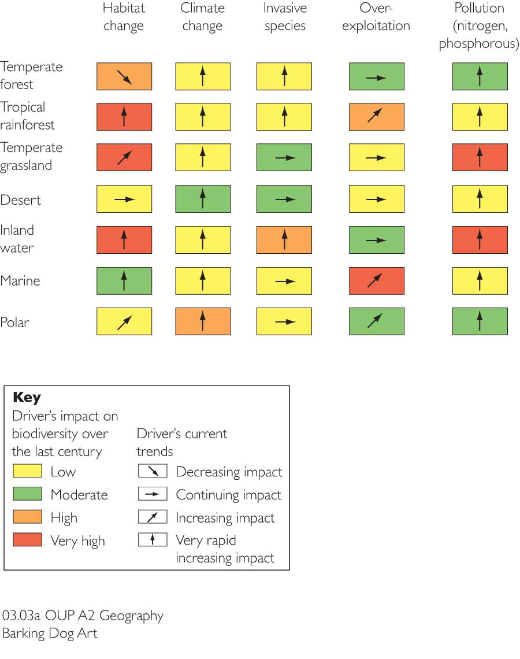

**What is the image to the right showing? Explain it:**

(2 marks)

(10 marks)

|  |  |
| --- | --- |
| **Threat** | **Explain why this is a threat (at least 2 points per threat)** |
| **Habitat Change** |  |
| **Over-Exploitation** |  |
| **Invasive Species** |  |
| **Pollution** |  |
| **Climate Change** |  |

**In your opinion, which is the biggest named threat to ecosystems & why**? (3 marks)

_____

**Three named hotspots under threat:** (9 marks)

|  |  |
| --- | --- |
| **Hotspot** | **Explain why they are threatened and where they are located (at least 3 points per Hotspot)** |
| **The Caucasus** |  |
| **Southwest Australia** |  |
| **Atlantic Forest** |  |